Implementation of Wavelet Neural Network for Forecasting Electricity Consumption

|  |  |
| --- | --- |
|  |  |

***Abstract-This paper proposes a method for forecasting the monthly electrical consumption is an attempt to optimize energy production by predicting the electricity consumption based on the past data by implementing the stochastic recurrent network. It implements DWT which is used to extract information from the signal in combination with Stochastic Recurrent Wavelet Neural Network (SRWNN) where the information is fed to predict the consumptions based on the past data signal.***

I. Introduction

From the ancient times, human demand for energy in different forms was always high. When civilization did not exist the significant form of energy was fire, but when enlightenment occurred, and electricity discovered, energy consumption multiplied, added to this industrial revolution in the late 1900s lead to the fast growth of energy consumption majorly in the form of electricity.

In the present scenario, the non-renewable form of energy is on the verge of extinction, and renewable form of energy is insufficient to meet the current demands of electricity. High demands of energy is supported by the fact that average monthly power consumption in households has reached to 230 kWh in Korea[1]. Similarly, in UK domestic energy consumption in 2004 was responsible for 27% of total energy[2]. Thus, the conservation and prediction of electricity consumption to meet the needs of the present as well as of the future is essential. This paper proposes a new model and implements it with high accuracy to predict the consumption of electricity in the city.

Implementing wavelet neural network for forecasting the monthly electrical consumption is an attempt to optimize the energy production by predicting the energy consumption based on the past data by implementing stochastic recurrent network (SRWNN)[3]. SRWNN is the hybrid model of the conventional WNN architecture. The paper implements SRWNN in combination with DWT to perform time series prediction on the dataset. The DWT is used to extract and decompose into subseries of different frequencies, and SRWNN was established by the random initialization of weights [3].

SRWNN is one of the new developments in the field of WNN. In the past, several WNN architectures has been proposed in the literature[4]–[7] and WNN has demonstrated its generality and reliability in these and various other fields[8]–[13]. WA is limited to small dimensions which is a major drawback and NN ’s due to random initialization lead to large training period[14]. The main motivate of WNN which is the generalization of RBFN[15], [16] is all about overcoming the overfitting problems of conventional Neural network algorithms[17] because WNN in combination with time-frequency localization properties, it has better error-tolerance and approximation[18]. Although, WNN model has a drawback of difficulty in selecting the mother wavelet function[19]. In this paper, we have proposed SRWNN with Morlet as mother wavelet function.

II. About the Dataset and data pre-processing

The Dataset used in the paper comprises of the electrical consumption of the people of a hypothetical city Electrovania [20]. The trainingdatasetconsists of data of the first 23 days of the month. We are then predicting the consumption of 24th day of the month. It contains various parameters such astemperature*,* Pressure, wind-speed, date-time, and variables 1, 2. The data is first preprocessed using DWT, and the detail coefficient and approximation of the signal is extracted and that is fed as an input to the network. In DWT the input signal is a 1-D input signal which is fed to the wavelet transform and resultant approximated signal is obtained.

We used MATLAB wavelet analyzer for decomposing the signal into detailed and approximated components. The rest of the programming was done using Python version 3.6.7.

III. ARCHITECTURE

1. **Discrete Wavelet Transform**

Wavelet Transformation is a popularly used mathematical tool which has application in various fields such as signal denoising, time-scale decomposition, image processing, density estimation, image compression.

Wavelet Transform are of two types: Continuous WT which is given by:

$W_{ψ}\left(a,b\right)=\sqrt{1/a}\int_{-∞}^{+∞}{}x\left(t\right)ψ^{*} \left(\frac{t-a}{b}\right)dt, a>0 (1)$

The Discrete WT is given by:

$W_{ψ}\left(m , n\right)=2^{-m/2}\sum_{t=0}^{T-1}{}x\left(t\right)ψ\left(\frac{t-n2^{m}}{2^{m}}\right)$ (2)

where T symbolize the length of the given signal, t signifies to discrete time index, integer variables x and y are scaling factor and translation factor variables of the DWT are p and q respectively, where p = 2x and q = y2x accordingly.

In the decomposition process, the initial signal is passed through a the low-resolution filter and high-resolution filter, which are classified as approximation component and detail component respectively, and they are much more stable compared to original signal.

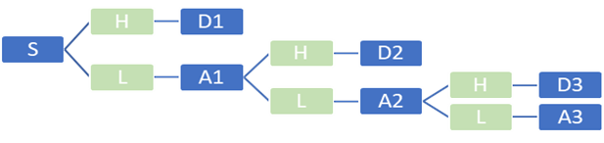

**Fig. 1:** Original Signal Decomposition into approximate and detailed components.

The signal can be reproduced (RS) by combining the approximate components and detailed components and is given by: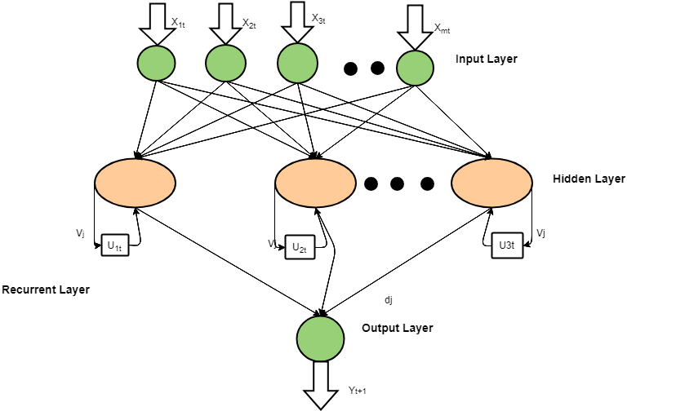

$S=d_{1}+a_{1}=d_{1}+d_{2}+a_{2}=d_{1}+d_{2}+d_{3}+a_{3}=….$

1. **Stochastic Recurrent Wavelet Neural Network**

In order to achieve keep track of the time-series forecasting, we have applied a novel stochastic recurrent neural network (SRWNN) whose model is derived from Wavelet Neural network (WNN). The structure of SRWNN comprising of input layer which comprise of input variable xit ( i = 1 , 2 , . . . , m ) at time t , a hidden layer which comprise of output variable zjt ( j = 1 , 2 , . . . , n ) at time t , a recurrent layer which comprise of variable ujt ( j = 1 , 2 , . . . , n ) at time t and a output layer with the network output yt+1 at time t+1.

The input to hidden layer:

$h_{jt}\left(k\right)=1/a_{j}\left(\sum_{i=1}^{m}{}w_{ij}x_{it}\left(k\right)-b_{j}\right)+\sum_{i=1}^{n}{}v_{j}u_{jt}\left(k\right)$ (3)

$u_{jt}\left(k\right)= z_{jt}\left(k-1\right), i = 1,2,..,m, j = 1,2,....,m$

where wij is the weight linked with input nodes i and the hidden nodes j. vij is the weight linked by the hidden nodes j to the recurrent nodes j, aj is the scaling factor, and bj is the translation factor of the nodes j in hidden layer respectively. Then the output of the hidden layer nodes j is characterized as follows:

$z_{it}\left(k\right)=ψ_{a,b}\left(h_{jt}\left(k\right)\right)=\left(1/a_{j}\left(\sum_{i=1}^{m}{}w_{ij}x_{it}\left(k\right)-b_{j}\right)+\sum_{i=1}^{n}{}v_{j}u_{jt}\left(k\right)\right) (4)$

where ψ(x) is the mother wavelet of the SRWNN model. We used Morlet wavelet as the activation function is given by:

$ψ\left(x\right)=coscos \left(1.75x\right) expexp \left\{-x^{2}/2\right\}$ (5)

The output is given by:

$y_{t+1}\left(k\right)=\sum_{j=1}^{n}{}d_{j}z_{jt}\left(k\right)=\sum_{j=1}^{n}{}d_{j}ψ_{a,b}\left(h_{jt}\left(k\right)\right)$ (6)

**Fig. 2:** Single node of Stochastic Recurrent Wavelet Neural Network Model

The error of the output is given by $ε_{t_{n}}=F_{t_{n}}-O_{t_{n}}$. Therefore, the cost function of the set can be described as: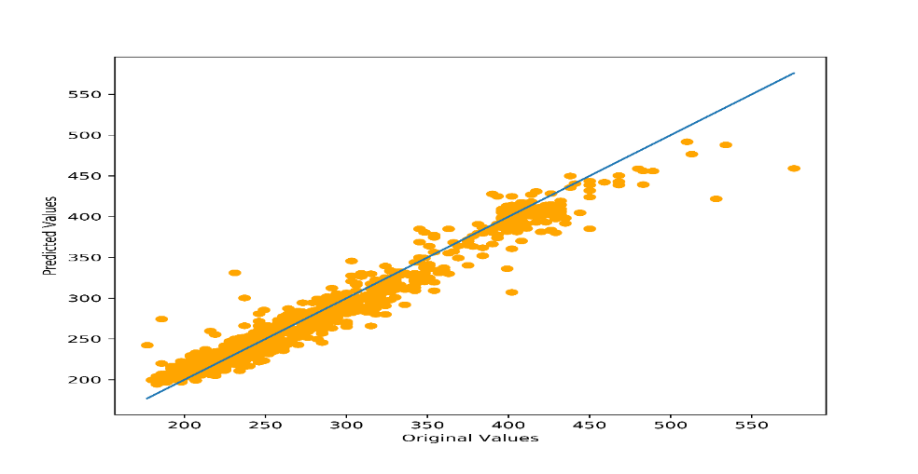

$E\left(t_{n}\right)=1/2φ\left(t_{n}\right)ε_{t_{n}}^{2}=1/2φ\left(t_{n}\right){\left(F_{t_{n}}-O_{t_{n}}\right)}^{2}$ (7)

where G(tn) is the stochastic time effective function. The definition is described as follows:

$G\left(t_{n}\right)=1/αexpexp \{ -\int_{t_{n}}^{t_{1}}{}μ(t)ⅆt-\int_{t_{n}}^{t_{1}}{}σ(t)dB(t)\}$ (8)

The architecture of the Stochastic Recurrent WNN is as given in fig. After the time-Series is decomposed using Wavelet decomposition, the individual signals with their multiple attributes(x1t,x2t,...xmt ) in the figure 2. are then fed into the network. The network then predicts the output(Yt+1).

The recurrent layers with weights(U1t, U2t..Unt) help to take into account the previous activation values in the new activation calculation. This recurrence helps in improving the model accuracy.

Once all values are predicted for the individual decompositions, they are aggregated to give the final result as shown in the fig 3.

**Fig. 3:** Implementation of SRWNN model to Predict Electricity Consumption. All the outputs from the individual nodes are aggregated.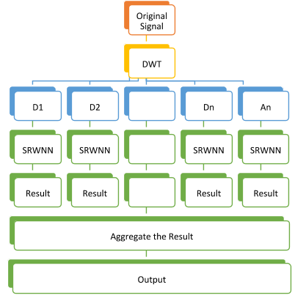

**Fig. 4**: Regression plot of the original signal corresponding to the original and predicted values

IV. RESULTS  
  
The Regression plot of the original signal and the predicted values is shown in fig.4.  
  
The analysis between the forecasted results and each subseries of electricity consumption is illustrated in fig.5:

|  |  |
| --- | --- |
| Error | Values |
| MAPE | 4.9287 |
| SMAPE | 5.0073 |
| TIC | 0.0537 |
| R | 0.9627 |

**Table 1**: Table showing various metrics and corresponding values calculated from the model.

Fig.5 show the various decompositions. The blue ones are the original ones while the orange ones are the predicted. As you can see the noisier the signal is, more it is difficult to get an accurate prediction.

Fig.5(e) is the accumulated signal after 4 decompositions, while the Fig.5(f) is the final aggregated output.

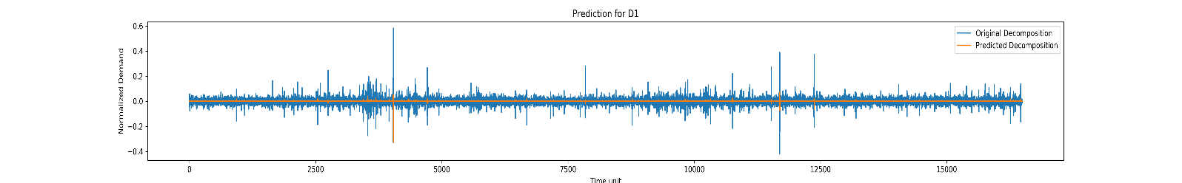

**Fig. 5 (a)**

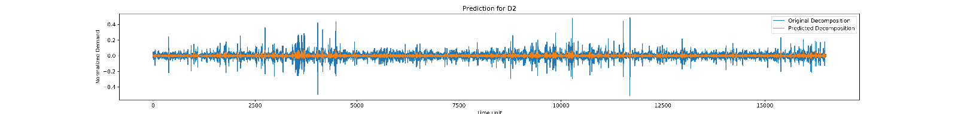

**Fig. 5 (b)**

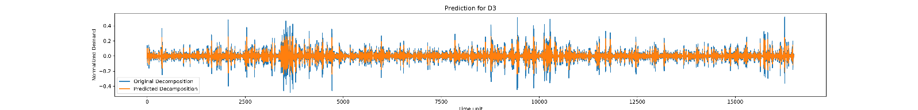

**Fig. 5 (c)**

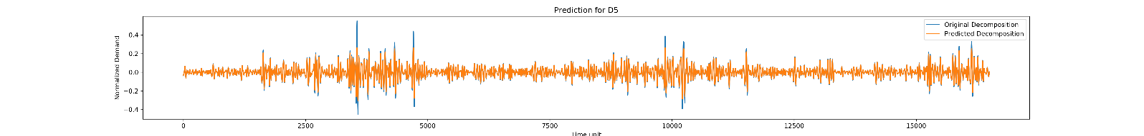

**Fig. 5 (d)**

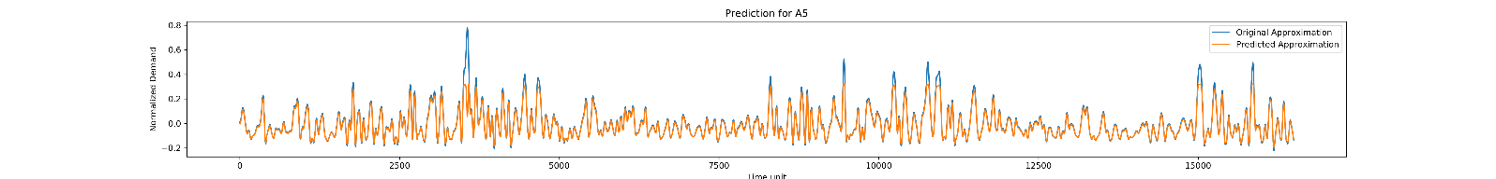

**Fig. 5 (e)**

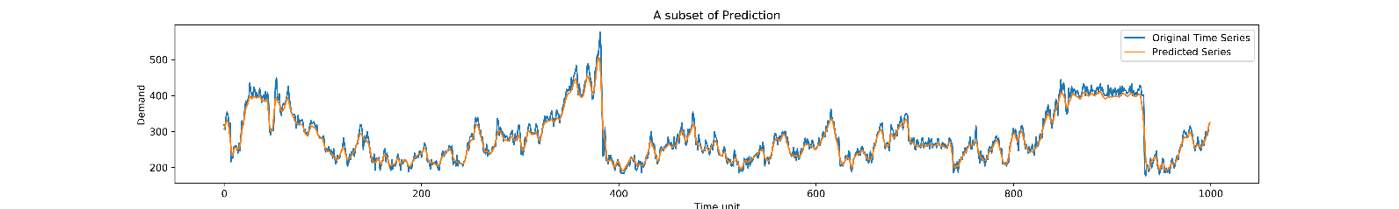

**Fig. 5 (f)**

**Fig. 5:** Original and Predicted Decompositions(a-d), Accumulated signal(e) and the final aggregated signal(f)

V. CONCLUSION

The paper proposes a new method to predict the electricity consumption using SRWNN-DWT method. DWT is used to extricate the information from the time-series signal. The recurrent layer is implemented with the aim to improve the computation time. The simulation results demonstrate that the prediction made on the time-series signal of the electricity consumption can provide stable and satisfactory results and have a great scope in the future.

Combining the network with LSTM may further improve the network so can employ other wavelets in the network. Using weight initialization methods such as Back Elimination may further help the network reach the global minimum as well as reduce the training time.

References

[1] M. J. Kim, “Characteristics and determinants by electricity consumption level of households in Korea,” *Energy Reports*, vol. 4, pp. 70–76, 2018.

[2] A. Druckman and T. Jackson, “Household energy consumption in the UK: A highly geographically and socio-economically disaggregated model,” *Energy Policy*, vol. 36, no. 8, pp. 3167–3182, 2008.

[3] L. Huang and J. Wang, “Forecasting energy fluctuation model by wavelet decomposition and stochastic recurrent wavelet neural network,” *Neurocomputing*, vol. 309, pp. 70–82, 2018.

[4] L. Jiao, J. Pan, and Y. Fang, “Multiwavelet neural network and its approximation properties,” *IEEE Trans. Neural Networks*, vol. 12, no. 5, pp. 1060–1066, 2001.

[5] C. J. Lin, “Nonlinear systems control using self-constructing wavelet networks,” *Appl. Soft Comput. J.*, vol. 9, no. 1, pp. 71–79, 2009.

[6] Y. Chen, B. Yang, and J. Dong, “Time-series prediction using a local linear wavelet neural network,” *Neurocomputing*, vol. 69, no. 4–6, pp. 449–465, 2006.

[7] E. O. Ari and E. Kocaoglan, “An SRWNN-based approach on developing a self-learning and self-evolving adaptive control system for motion platforms,” *Int. J. Control*, vol. 89, no. 2, pp. 380–396, 2016.

[8] L. Wu, B. Yao, Z. Peng, and Y. Guan, “Fault Diagnosis of Roller Bearings Based on a Wavelet Neural Network and Manifold Learning,” *Appl. Sci.*, vol. 7, no. 2, p. 158, 2017.

[9] Y. Zhenghui, W. Shuaimin, X. Yujing, and L. Bei, “The Application of Wavelet Neural Network in the Settlement Monitoring of Subway,” *TELKOMNIKA (Telecommunication Comput. Electron. Control.*, vol. 15, no. 1, p. 109, 2017.

[10] F. A. Shah and L. Debnath, “Wavelet neural network model for yield spread forecasting,” *Mathematics*, vol. 5, no. 4, 2017.

[11] U. Okkan, “Wavelet neural network model for reservoir inflow prediction,” *Sci. Iran.*, vol. 19, no. 6, pp. 1445–1455, 2012.

[12] R. Rahimi molkdaragh, S. Jafarmadar, S. Khalilaria, and H. Soukht Saraee, “Prediction of the performance and exhaust emissions of a compression ignition engine using a wavelet neural network with a stochastic gradient algorithm,” *Energy*, vol. 142, pp. 1128–1138, 2018.

[13] Z. Zainuddin and P. Ong, “Optimization of wavelet neural networks with the firefly algorithm for approximation problems,” *Neural Comput. Appl.*, vol. 28, no. 7, pp. 1715–1728, 2017.

[14] A. K. Alexandridis and A. D. Zapranis, “Wavelet neural networks: A practical guide,” *Neural Networks*, vol. 42, pp. 1–27, 2013.

[15] Y. Wu, H. Wang, B. Zhang, and K.-L. Du, “Using Radial Basis Function Networks for Function Approximation and Classification,” *ISRN Appl. Math.*, vol. 2012, pp. 1–34, 2012.

[16] S.-T. L. S.-T. Li and S.-C. C. S.-C. Chen, “Function approximation using robust wavelet neural networks,” *14th IEEE Int. Conf. Tools with Artif. Intell. 2002 ICTAI 2002 Proc.*, pp. 483–488, 2002.

[17] Z. Zhang and M. A. Kon, “Wavelet sampling and generalization in neural networks,” *Neurocomputing*, vol. 267, pp. 36–54, 2017.

[18] G. Lihong, X. Gening, Y. Ping, Y. Qiang, and Z. Min, “Study on the stress statistics and its reliability of the structure based on WNN,” *Inf. Technol. J.*, vol. 39, no. 5, pp. 561–563, 2013.

[19] G. Wang, L. Guo, and H. Duan, “Wavelet Neural Network Using Multiple Wavelet Functions in Target Threat Assessment,” *Sci. World J.*, vol. 2013, pp. 1–7, 2013.

[20] [*https://www.kaggle.com/utathya/ann-on-electricity-*](https://www.kaggle.com/utathya/ann-on-electricity-) *consumption/data*” .